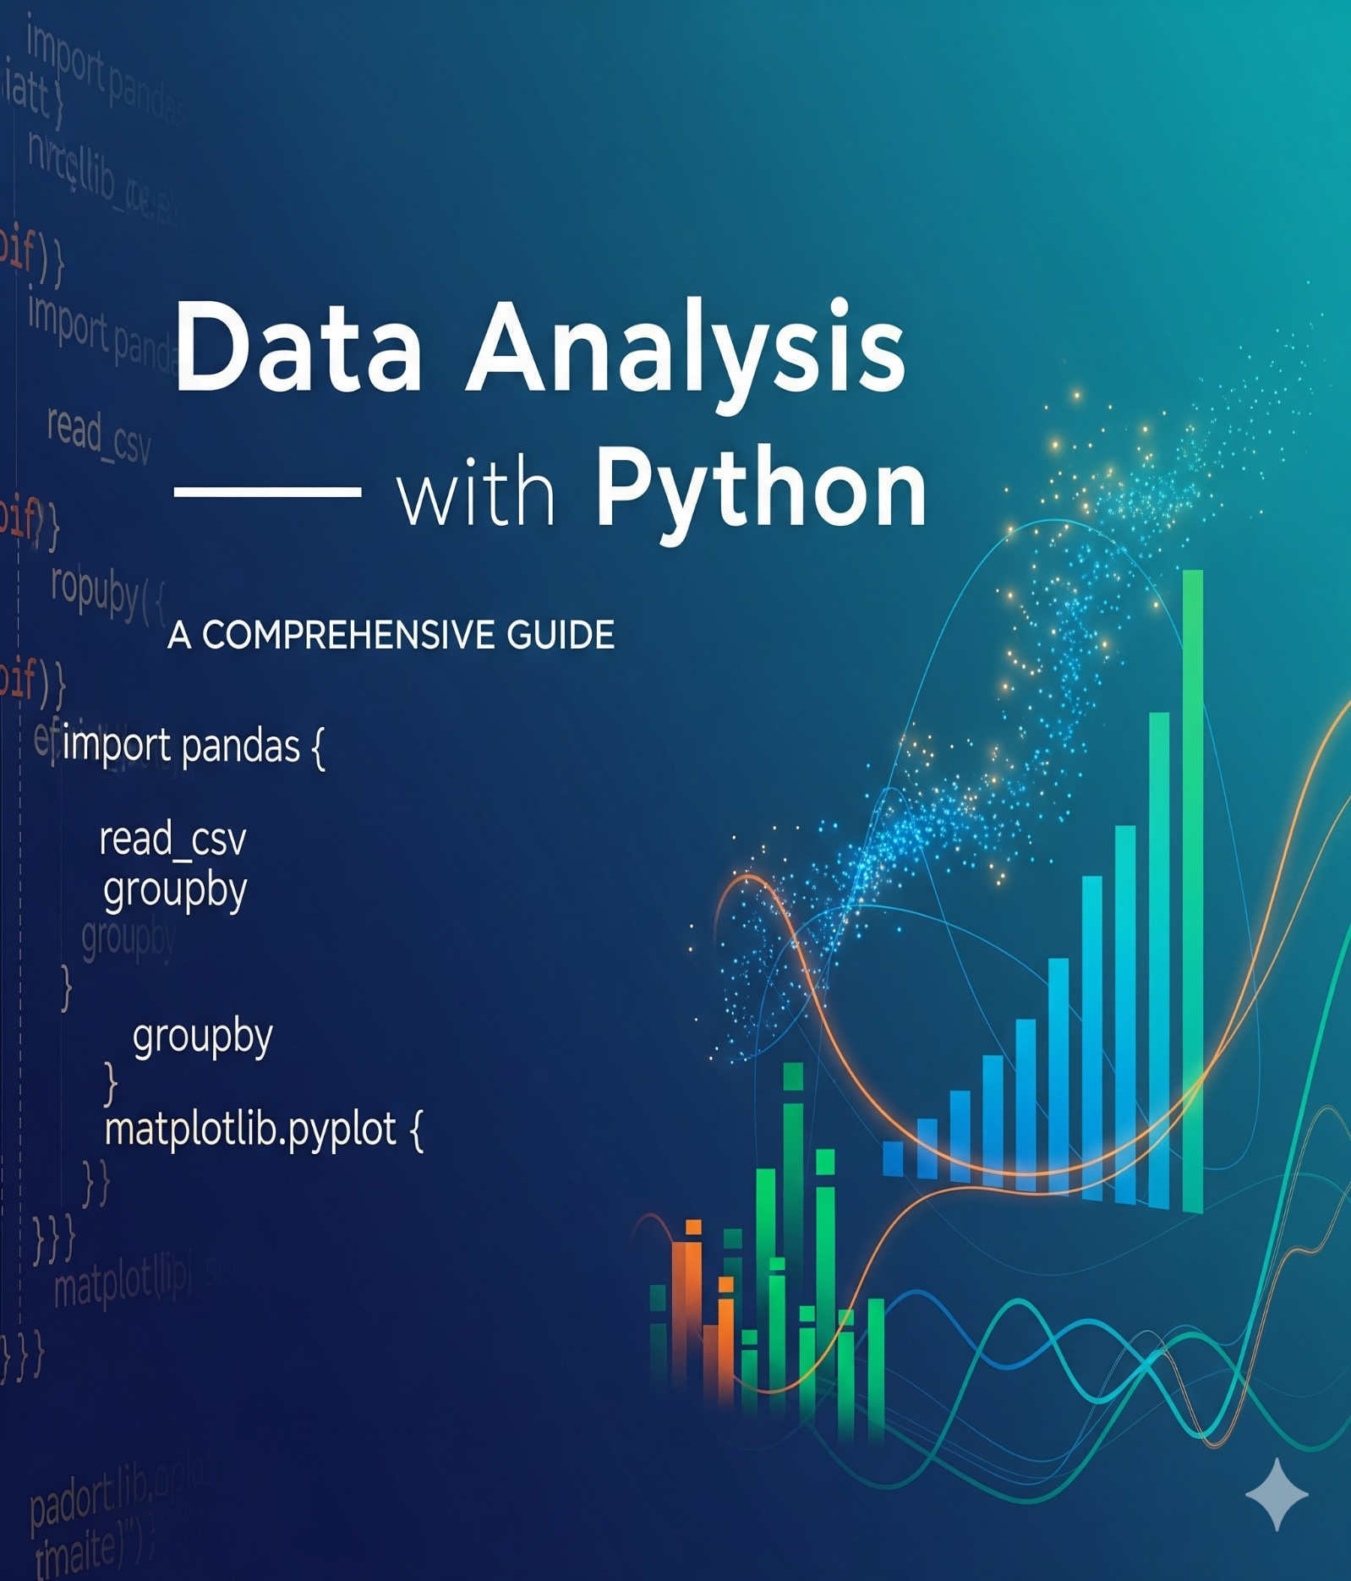

Data Analysis with Python

Data Analysis is the technique of collecting, transforming and organizing data to make future predictions and informed data-driven decisions. It also helps to find possible solutions for a business problem.

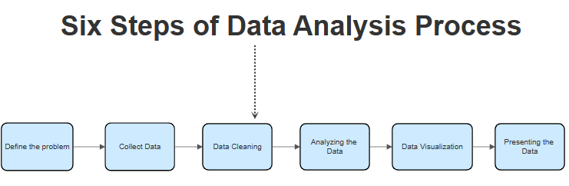
Six Steps of Data Analysis Process

- Define the Problem or Research Question
- Collect Data
- Data Cleaning
- Analysing the Data
- Data Visualization
- Presenting Data
Each step has its own process and tools to make overall conclusions based on the data.

Step 1. Define the Problem or Research Question
In the first step of process the data analyst is given a problem/business task. The analyst has to understand the task and the stakeholder's expectations for the solution. A stakeholder is a person that has invested their money and resources to a project. The analyst must be able to ask different questions in order to find the right solution to their problem. The analyst has to find the root cause of the problem in order to fully understand the problem. The analyst must make sure that he/she doesn't have any distractions while analysing the problem. Communicate effectively with the stakeholders and other colleagues to completely understand what the underlying problem is.

Step 2. Data Collection
The second step is to Prepare or Collect the Data. This step includes collecting data and storing it for further analysis. The analyst has to collect the data based on the task given from multiple sources. The data has to be collected from various sources, internal or external sources.
Internal data is the data available in the organization that you work for while external data is the data available in sources other than your organization.
- The data that is collected by an individual from their own resources is called first-party data.
- The data that is collected and sold is called second-party data.
- Data that is collected from outside sources is called third-party data.
The common sources from where the data is collected are Interviews, Surveys, Feedback, Questionnaires. The collected data can be stored in a spreadsheet or SQL database.

Step 3. Data Cleaning
The third step is Clean and Process Data. After the data is collected from multiple sources, it is time to clean the data. Clean data means data that is free from misspellings, redundancies, and irrelevance. Clean data largely depends on data integrity.
- There might be duplicate data or the data might not be in a format, therefore the unnecessary data is removed and cleaned.
- There are different functions provided by SQL and Excel to clean the data.
This is one of the most important steps in Data Analysis as clean and formatted data helps in finding trends and solutions. The most important part of the Process phase is to check whether your data is biased or not. Bias is an act of favoring a particular group/community while ignoring the rest. Biasing is a big no-no as it might affect the overall data analysis. The data analyst must make sure to include every group while the data is being collected.

Step 4. Analysing the Data
The fourth step is to Analyse. The cleaned data is used for analyzing and identifying trends. It also performs calculations and combines data for better results. The tools used for performing calculations are Excel or SQL. These tools provide in-built functions to perform calculations or sample code is written in SQL to perform calculations.
Using Excel, we can create pivot tables and perform calculations while SQL creates temporary tables to perform calculations.
Programming languages are another way of solving problems

Step 5. Data Visualization
The fifth step is visualizing the data. Nothing is more compelling than a visualization. The data now transformed has to be made into a visual (chart, graph). The reason for making data visualizations is that there might be people, mostly stakeholders that are non-technical. Visualizations are made for a simple understanding of complex data.
- Tableau and Looker are the two popular tools used for compelling data visualizations. Tableau is a simple drag and drop tool that helps in creating compelling visualizations.
- Looker is a data viz tool that directly connects to the database and creates visualizations.
Tableau and Looker are both equally used by data analysts for creating a visualization. R and Python have some packages that provide beautiful data visualizations. R has a package named ggplot which has a variety of data visualizations. A presentation is given based on the data findings. Sharing the insights with the team members and stakeholders will help in making better decisions. It helps in making more informed decisions and it leads to better outcomes.

Step 6. Presenting the Data
Presenting the data involves transforming raw information into a format that is easily comprehensible and meaningful for various stakeholders. This process encompasses the creation of visual representations, such as charts, graphs, and tables, to effectively communicate patterns, trends, and insights gleaned from the data analysis.
The goal is to facilitate a clear understanding of complex information, making it accessible to both technical and non-technical audiences. Effective data presentation involves thoughtful selection of visualization techniques based on the nature of the data and the specific message intended. It goes beyond mere display to storytelling, where the presenter interprets the findings, emphasizes key points, and guides the audience through the narrative that the data unfolds.

Analysing Numerical Data with NumPy
NumPy is an array processing package in Python and provides a high-performance multidimensional array object and tools for working with these arrays. It is the fundamental package for scientific computing with Python.

Arrays in NumPy
NumPy Array is a table of elements usually numbers, all of the same types, indexed by a tuple of positive integers. In Numpy the number of dimensions of the array is called the rank of the array. A tuple of integers giving the size of the array along each dimension is known as the shape of the array.

Creating NumPy Array
NumPy arrays can be created in multiple ways with various ranks. It can also be created with the use of different data types like lists, tuples, etc. The type of the resultant array is deduced from the type of elements in the sequences. NumPy offers several functions to create arrays with initial placeholder content. This minimizes the necessity of growing arrays.
We can create array using numpy.empty(shape, dtype=float, order='C')
import numpy as np
​
a = np.empty([2, 2], dtype = int)
print("\nMatrix a : \n", a)
​
b = np.empty(2, dtype = int)
print("Matrix b : \n", b)
Output
Matrix a :
[[ 94655291709206 0]
[3543826506195694713 34181816989462323]]
Matrix b :
[-4611686018427387904 206158462975]

Create Array using numpy.zeros(shape, dtype = None, order = 'C')
import numpy as np
​
a = np.zeros([2, 2], dtype = int)
print("\nMatrix a : \n", a)
​
b = np.zeros(2, dtype = int)
print("Matrix b : \n", b)

c = np.zeros([3, 3])
print("\nMatrix c : \n", c)
Output
Matrix a :
[[0 0]
[0 0]]
Matrix b :
[0 0]

Matrix c :
[[0. 0. 0.]
[0. 0. 0.]
[0. 0. 0.]]

Operations on Numpy Arrays

Arithmetic Operations

1. Addition:
import numpy as np
​
a = np.array([5, 72, 13, 100])
b = np.array([2, 5, 10, 30])
​
add_ans = a+b
print(add_ans)
​
add_ans = np.add(a, b)
print(add_ans)
​
c = np.array([1, 2, 3, 4])
add_ans = a+b+c
print(add_ans)
​
add_ans = np.add(a, b, c)
print(add_ans)
Output
[ 7 77 23 130]
[ 7 77 23 130]
[ 8 79 26 134]
[ 7 77 23 130]

2. Subtraction:
import numpy as np
​
a = np.array([5, 72, 13, 100])
b = np.array([2, 5, 10, 30])
​
sub_ans = a-b
print(sub_ans)
​
sub_ans = np.subtract(a, b)
print(sub_ans)
Output
[ 3 67 3 70]
[ 3 67 3 70]

3. Multiplication:
import numpy as np
​
a = np.array([5, 72, 13, 100])
b = np.array([2, 5, 10, 30])
​
mul_ans = a*b
print(mul_ans)
​
mul_ans = np.multiply(a, b)
print(mul_ans)
Output
[ 10 360 130 3000]
[ 10 360 130 3000]

4. Division:
import numpy as np
​
a = np.array([5, 72, 13, 100])
b = np.array([2, 5, 10, 30])
​
div_ans = a/b
print(div_ans)
​
div_ans = np.divide(a, b)
print(div_ans)
Output
[ 2.5 14.4 1.3 3.33333333]
[ 2.5 14.4 1.3 3.33333333]

NumPy Array Indexing
Indexing can be done in NumPy by using an array as an index. In the case of the slice, a view or shallow copy of the array is returned but in the index array, a copy of the original array is returned. Numpy arrays can be indexed with other arrays or any other sequence with the exception of tuples. The last element is indexed by -1 second last by -2 and so on.
import numpy as np
​
a = np.arange(10, 1, -2)
print("\n A sequential array with a negative step: \n",a)
​
newarr = a[np.array([3, 1, 2 ])]
print("\n Elements at these indices are:\n",newarr)
Output
A sequential array with a negative step:
[10 8 6 4 2]

Elements at these indices are:
[4 8 6]

NumPy Array Slicing
Consider the syntax x[obj] where x is the array and obj is the index. The slice object is the index in the case of basic slicing. Basic slicing occurs when obj is:
- a slice object that is of the form start: stop: step
- an integer
- or a tuple of slice objects and integers
All arrays generated by basic slicing are always the view in the original array.
import numpy as np
​
a = np.arange(20)
print("\n Array is:\n ",a)
​
print("\n a[-8:17:1] = ",a[-8:17:1])
​
print("\n a[10:] = ",a[10:])
Output
Array is:
[ 0 1 2 3 4 5 6 7 8 9 10 11 12 13 14 15 16 17 18 19]

a[-8:17:1] = [12 13 14 15 16]

a[10:] = [10 11 12 13 14 15 16 17 18 19]
import numpy as np
​
a = np.arange(20)
print("\n Array is:\n ",a)
​
print("\n a[-8:17:1] = ",a[-8:17:1])
​
print("\n a[10:] = ",a[10:])
Output
Array is:
[ 0 1 2 3 4 5 6 7 8 9 10 11 12 13 14 15 16 17 18 19]

a[-8:17:1] = [12 13 14 15 16]

a[10:] = [10 11 12 13 14 15 16 17 18 19]
Ellipsis can also be used along with basic slicing. Ellipsis (…) is the number of : objects needed to make a selection tuple of the same length as the dimensions of the array.
import numpy as np
​
b = np.array([[[1, 2, 3],[4, 5, 6]],
[[7, 8, 9],[10, 11, 12]]])
​
print(b[...,1])
Output
[[ 2 5]
[ 8 11]]

NumPy Array Broadcasting
The term broadcasting refers to how numpy treats arrays with different Dimensions during arithmetic operations which lead to certain constraints, the smaller array is broadcast across the larger array so that they have compatible shapes.
Let’s assume that we have a large data set, each datum is a list of parameters. In Numpy we have a 2-D array where each row is a datum and the number of rows is the size of the data set. Suppose we want to apply some sort of scaling to all these data every parameter gets its own scaling factor or say Every parameter is multiplied by some factor.
Just to have a clear understanding, let’s count calories in foods using a macro-nutrient breakdown. Roughly put, the caloric parts of food are made of fats (9 calories per gram), protein (4 CPG) and carbs (4 CPG). So if we list some foods (our data) and for each food list its macro-nutrient breakdown (parameters), we can then multiply each nutrient by its caloric value (apply scaling) to compute the caloric breakdown of every food item.
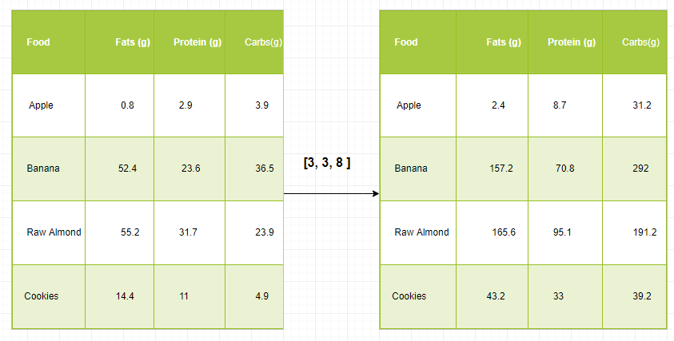
With this transformation, we can now compute all kinds of useful information. For example what is the total number of calories present in some food or, given a breakdown of my dinner know how many calories did I get from protein and so on.
Let’s see a naive way of producing this computation with Numpy:
import numpy as np
​
macros = np.array([
[0.8, 2.9, 3.9],
[52.4, 23.6, 36.5],
[55.2, 31.7, 23.9],
[14.4, 11, 4.9]
])
​
cal_per_macro = np.array([3, 3, 8])
​
result = macros * cal_per_macro
​
print(result)
Output
[[ 2.4 8.7 31.2]
[157.2 70.8 292. ]
[165.6 95.1 191.2]
[ 43.2 33. 39.2]]

Broadcasting Rules: Broadcasting two arrays together follow these rules:
- If the arrays don’t have the same rank then prepend the shape of the lower rank array with 1s until both shapes have the same length.
- The two arrays are compatible in a dimension if they have the same size in the dimension or if one of the arrays has size 1 in that dimension.
- The arrays can be broadcast together if they are compatible with all dimensions.
- After broadcasting, each array behaves as if it had a shape equal to the element-wise maximum of shapes of the two input arrays.
- In any dimension where one array had a size of 1 and the other array had a size greater than 1, the first array behaves as if it were copied along that dimension.
import numpy as np
​
v = np.array([12, 24, 36])
w = np.array([45, 55])
​
print(np.reshape(v, (3, 1)) * w)
​
X = np.array([[12, 22, 33], [45, 55, 66]])
​
print(X + v)
​
print((X.T + w).T)
​
print(X * 2)
Output
[[ 540 660]
[1080 1320]
[1620 1980]]
[[ 24 46 69]
[ 57 79 102]]
[[ 57 67 78]
[100 110 121]]
[[ 24 44 66]
[ 90 110 132]]

Analysing Data Using Pandas
Python Pandas Is used for relational or labelled data and provides various data structures for manipulating such data and time series. This library is built on top of the NumPy library. This module is generally imported as:
import pandas as pd
Here, pd is referred to as Pandas. However, it is not necessary to import the library using this, it just helps in writing less amount code every time a method or property is called. Pandas generally provide two data structures for manipulating data, they are:
- Series
- Data frame

Series
Pandas Series is a one-dimensional labeled array capable of holding data of any type like integer, string, float, python objects, etc. The axis labels are collectively called indexes. Pandas Series is nothing but a column in an excel sheet. Labels need not be unique but must be a hashable type. The object supports both integer and label-based indexing and provides a host of methods for performing operations involving the index.
Pandas Series
It can be created using the Series() function by loading the dataset from the existing storage like SQL, Database, CSV Files, Excel Files, etc or from data structures like lists, dictionaries, etc.
Python Pandas Creating Series
import pandas as pd
import numpy as np
​
ser = pd.Series(dtype="object")
​
print(ser)
​
data = np.array(['g', 'e', 'e', 'k', 's'])
​
ser = pd.Series(data)
print(ser)
Output
Series([], dtype: object)
0 g
1 e
2 e
3 k
4 s
dtype: object

Dataframe
Pandas DataFrame is a two-dimensional size mutable array with labeled axes (rows and columns). In this data is aligned in a tabular format in rows and columns. Pandas DataFrame consists of three principal components i.e data, rows and columns.
Python Pandas Creating Dataframe
import pandas as pd
​
df = pd.DataFrame()
print(df)
​
lst = ['Tech', 'For', 'Tech', 'is', 'portal', 'for', 'Tech']
​
df = pd.DataFrame(lst, columns=['Words'])
​
print(df)
Output
Empty DataFrame
Columns: []
Index: []
Words
0 Tech
1 For
2 Tech
3 is
4 portal
5 for
6 Tech

Creating Dataframe from CSV
We can create a dataframe from the CSV files using the read_csv() function.
import pandas as pd

df = pd.read_csv("Iris.csv")

df.head()
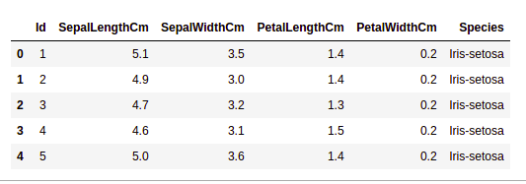
Output:

Filtering DataFrame
Pandas dataframe.filter() function is used to Subset rows or columns of dataframe according to labels in the specified index. Note that this routine does not filter a dataframe on its contents. The filter is applied to the labels of the index.
Python Pandas Filter Dataframe
import pandas as pd

df = pd.read_csv("Iris.csv")

df.filter(["Species", "SepalLengthCm", "SepalLengthCm"]).head()
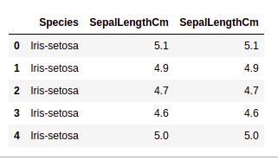
Output:

Sorting DataFrame
In order to sort the data frame in pandas, the function sort_values() is used. Pandas sort_values() can sort the data frame in Ascending or Descending order. Python Pandas Sorting Dataframe in Ascending Order
import pandas as pd
​
df = pd.read_csv("Iris.csv", header=None)
columns = ["Id", "SepalLengthCm", "SepalWidthCm", "PetalLengthCm", "PetalWidthCm", "Species"]
df.columns = columns
​
df_sorted = df.sort_values(by='SepalLengthCm', ascending=True)
​
print(df_sorted.head())

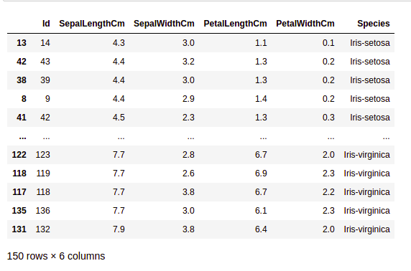

Pandas GroupBy
Groupby is a pretty simple concept. We can create a grouping of categories and apply a function to the categories. In real data science projects, you’ll be dealing with large amounts of data and trying things over and over, so for efficiency we use the Groupby concept. Groupby mainly refers to a process involving one or more of the following steps they are:
- Splitting: It is a process in which we split data into group by applying some conditions on datasets.
- Applying: It is a process in which we apply a function to each group independently.
- Combining: It is a process in which we combine different datasets after applying groupby and results into a data structure.

Python Pandas GroupBy:
import pandas as pd

data1 = {'Name': ['Jai', 'Anuj', 'Jai', 'Princi',
'Gaurav', 'Anuj', 'Princi', 'Abhi'],
'Age': [27, 24, 22, 32,
33, 36, 27, 32],
'Address': ['Nagpur', 'Kanpur', 'Allahabad', 'Kannuaj',
'Jaunpur', 'Kanpur', 'Allahabad', 'Aligarh'],
'Qualification': ['Msc', 'MA', 'MCA', 'Phd',
'B.Tech', 'B.com', 'Msc', 'MA']}

df = pd.DataFrame(data1)

print("Original Dataframe")
print(df)

gk = df.groupby('Name')

print("After Creating Groups")
gk.first()
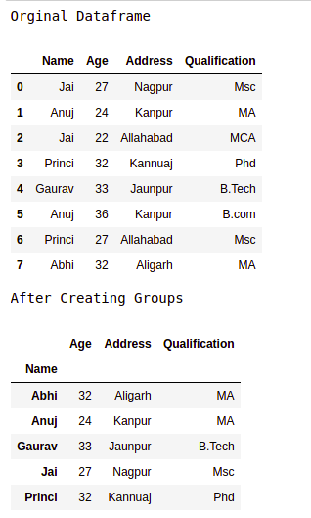
Output:

Applying function to group:
After splitting a data into a group, we apply a function to each group in order to do that we perform some operations they are:
- Aggregation: It is a process in which we compute a summary statistic (or statistics) about each group. For Example, Compute group sums or means
- Transformation: It is a process in which we perform some group-specific computations and return a like-indexed. For Example, Filling NAs within groups with a value derived from each group
- Filtration: It is a process in which we discard some groups, according to a group-wise computation that evaluates True or False. For Example, Filtering out data based on the group sum or mean

Pandas Aggregation
Aggregation is a process in which we compute a summary statistic about each group. The aggregated function returns a single aggregated value for each group. After splitting data into groups using groupby function, several aggregation operations can be performed on the grouped data.
import pandas as pd

data1 = {'Name': ['Jai', 'Anuj', 'Jai', 'Princi',
'Gaurav', 'Anuj', 'Princi', 'Abhi'],
'Age': [27, 24, 22, 32,
33, 36, 27, 32],
'Address': ['Nagpur', 'Kanpur', 'Allahabad', 'Kannuaj',
'Jaunpur', 'Kanpur', 'Allahabad', 'Aligarh'],
'Qualification': ['Msc', 'MA', 'MCA', 'Phd',
'B.Tech', 'B.com', 'Msc', 'MA']}

df = pd.DataFrame(data1)

grp1 = df.groupby('Name')

result = grp1['Age'].aggregate('sum')
print(result)
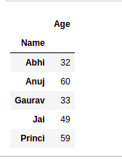
Output:

Concatenating DataFrame
In order to concat the dataframe, we use concat() function which helps in concatenating the dataframe. This function does all the heavy lifting of performing concatenation operations along with an axis of Pandas objects while performing optional set logic (union or intersection) of the indexes (if any) on the other axes.
import pandas as pd

data1 = {'key': ['K0', 'K1', 'K2', 'K3'],
'Name': ['Jai', 'Princi', 'Gaurav', 'Anuj'],
'Age': [27, 24, 22, 32]}

data2 = {'key': ['K0', 'K1', 'K2', 'K3'],
'Address': ['Nagpur', 'Kanpur', 'Allahabad', 'Kannuaj'],
'Qualification': ['Btech', 'B.A', 'Bcom', 'B.hons']}

df = pd.DataFrame(data1)
df1 = pd.DataFrame(data2)

res = pd.concat([df, df1], axis=1)
print(res)
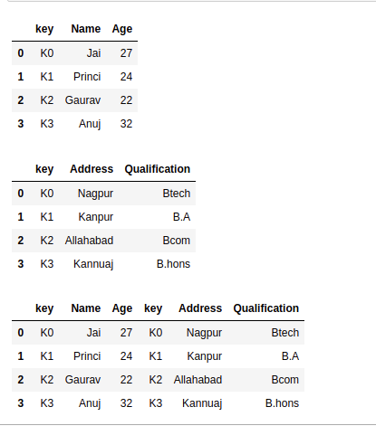
Output:

Merging DataFrame
When we need to combine very large DataFrames, joins serve as a powerful way to perform these operations swiftly. Joins can only be done on two DataFrames at a time, denoted as left and right tables. The key is the common column that the two DataFrames will be joined on. It’s a good practice to use keys that have unique values throughout the column to avoid unintended duplication of row values. Pandas provide a single function, merge(), as the entry point for all standard database join operations between DataFrame objects.
There are four basic ways to handle the join (inner, left, right and outer), depending on which rows must retain their data.
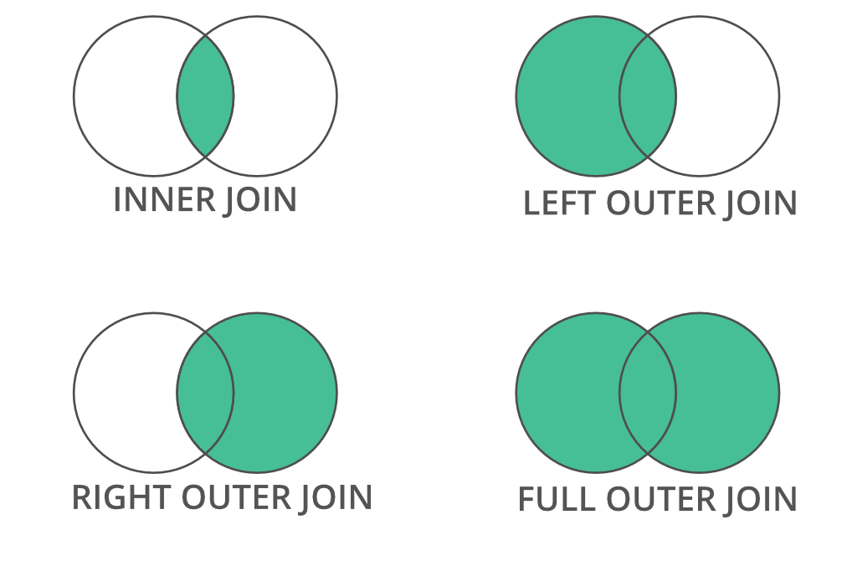
Python Pandas Merge Dataframe
import pandas as pd

data1 = {'key': ['K0', 'K1', 'K2', 'K3'],
'Name':['Jai', 'Princi', 'Gaurav', 'Anuj'],
'Age':[27, 24, 22, 32],}

data2 = {'key': ['K0', 'K1', 'K2', 'K3'],
'Address':['Nagpur', 'Kanpur', 'Allahabad', 'Kannuaj'],
'Qualification':['Btech', 'B.A', 'Bcom', 'B.hons']}

df = pd.DataFrame(data1)
df1 = pd.DataFrame(data2)

display(df,df1)

res = pd.merge(df, df1, on='key')
print(res)
Output:
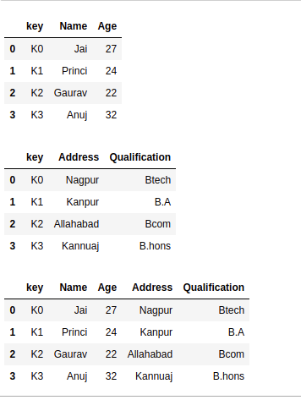

Joining DataFrame
In order to join the dataframe, we use .join() function this function is used for combining the columns of two potentially differently indexed DataFrames into a single result DataFrame.
import pandas as pd

data1 = {'Name':['Jai', 'Princi', 'Gaurav', 'Anuj'],
'Age':[27, 24, 22, 32]}

data2 = {'Address':['Allahabad', 'Kannuaj', 'Allahabad', 'Kannuaj'],
'Qualification':['MCA', 'Phd', 'Bcom', 'B.hons']}

df = pd.DataFrame(data1,index=['K0', 'K1', 'K2', 'K3'])
df1 = pd.DataFrame(data2, index=['K0', 'K2', 'K3', 'K4'])

res = df.join(df1)
print(res)
Output:
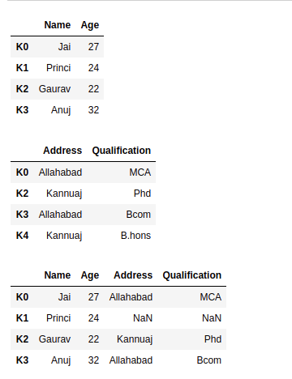

Visualization with Matplotlib
Matplotlib is easy to use and an amazing visualizing library in Python. It is built on NumPy arrays and designed to work with the broader SciPy stack and consists of several plots like line, bar, scatter, histogram, etc.

Pyplot
Pyplot is a Matplotlib module that provides a MATLAB-like interface. Pyplot provides functions that interact with the figure i.e. creates a figure, decorates the plot with labels and creates a plotting area in a figure.
import matplotlib.pyplot as plt

plt.plot([1, 2, 3, 4], [1, 4, 9, 16])
plt.axis([0, 6, 0, 20])
plt.show()

Bar chart
A bar plot or bar chart is a graph that represents the category of data with rectangular bars with lengths and heights that is proportional to the values which they represent. The bar plots can be plotted horizontally or vertically. A bar chart describes the comparisons between the discrete categories. It can be created using the bar() method.
Here we will use the iris dataset only.
import matplotlib.pyplot as plt
import pandas as pd

df = pd.read_csv("Iris.csv")

plt.bar(df['Species'], df['SepalLengthCm'])

plt.title("Iris Dataset")

plt.legend(["bar"])
plt.show()
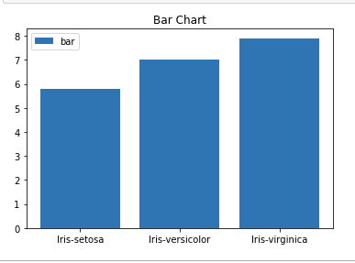
Output:

Histograms
A histogram is basically used to represent data in the form of some groups. It is a type of bar plot where the X-axis represents the bin ranges while the Y-axis gives information about frequency. To create a histogram the first step is to create a bin of the ranges, then distribute the whole range of the values into a series of intervals and count the values which fall into each of the intervals. Bins are clearly identified as consecutive, non-overlapping intervals of variables. The hist() function is used to compute and create a histogram of x.
import matplotlib.pyplot as plt
import pandas as pd

df = pd.read_csv("Iris.csv")

plt.hist(df["SepalLengthCm"])

plt.title("Histogram")

plt.legend(["SepalLengthCm"])
plt.show()
Output:
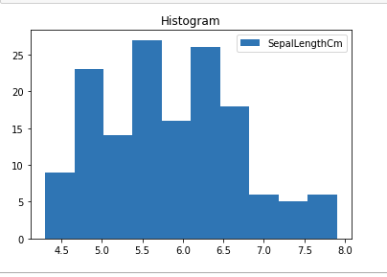

Scatter Plot
Scatter plots are used to observe relationship between variables and uses dots to represent the relationship between them. The scatter() method in the matplotlib library is used to draw a scatter plot.t
import matplotlib.pyplot as plt
import pandas as pd

df = pd.read_csv("Iris.csv")

plt.scatter(df["Species"], df["SepalLengthCm"])

plt.title("Scatter Plot")

plt.legend(["SepalLengthCm"])
plt.show()
Output:
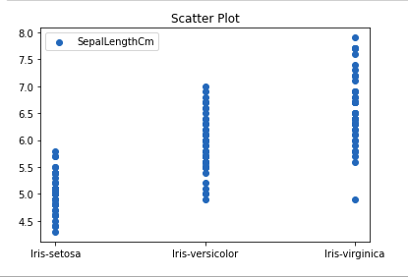

Box Plot
A boxplot is also known as a box and whisker plot. It is a very good visual representation when it comes to measuring the data distribution. Clearly plots the median values, outliers and the quartiles. Understanding data distribution is another important factor which leads to better model building. If data has outliers, box plot is a recommended way to identify them and take necessary actions. The box and whiskers chart shows how data is spread out. Five pieces of information are generally included in the chart
- The minimum is shown at the far left of the chart, at the end of the left ‘whisker’
- First quartile, Q1, is the far left of the box (left whisker)
- The median is shown as a line in the center of the box
- Third quartile, Q3, shown at the far right of the box (right whisker)
- The maximum is at the far right of the box
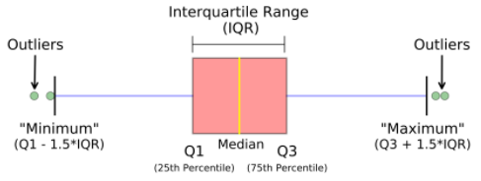
Representation of box plot
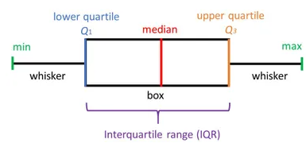
Python Matplotlib Box Plot
import matplotlib.pyplot as plt
import pandas as pd

df = pd.read_csv("Iris.csv")

plt.boxplot(df["SepalWidthCm"])

plt.title("Box Plot")

plt.legend(["SepalWidthCm"])
plt.show()
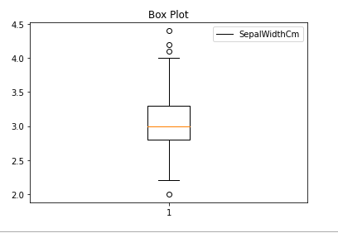
Output:

Correlation Heatmaps
A 2-D Heatmap is a data visualization tool that helps to represent the magnitude of the phenomenon in form of colors. A correlation heatmap is a heatmap that shows a 2D correlation matrix between two discrete dimensions, using colored cells to represent data from usually a monochromatic scale. The values of the first dimension appear as the rows of the table while the second dimension is a column. The color of the cell is proportional to the number of measurements that match the dimensional value. This makes correlation heatmaps ideal for data analysis since it makes patterns easily readable and highlights the differences and variation in the same data. A correlation heatmap, like a regular heatmap, is assisted by a colorbar making data easily readable and comprehensible.
Note: The data here has to be passed with corr() method to generate a correlation heatmap. Also, corr() itself eliminates columns that will be of no use while generating a correlation heatmap and selects those which can be used.
import matplotlib.pyplot as plt
import pandas as pd

df = pd.read_csv("Iris.csv")

plt.imshow(df.corr() , cmap = 'autumn' , interpolation = 'nearest' )

plt.title("Heat Map")
plt.show()
Output:
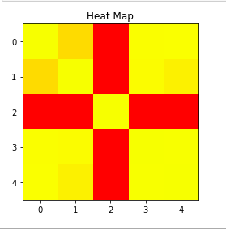

Exploratory Data Analysis
Exploratory Data Analysis (EDA) is a technique to analyze data using some visual Techniques. With this technique we can get detailed information about the statistical summary of the data. We will also be able to deal with the duplicates values, outliers and also see some trends or patterns present in the dataset.

Getting Information about the Dataset
We will use the shape parameter to get the shape of the dataset. We will be using Iris Dataset.
Shape of Dataframe
df.shape
Output:
(150, 6)
We can see that the dataframe contains 6 columns and 150 rows.
Now, let's also the columns and their data types. For this, we will use the info() method.
Information about Dataset
df.info()
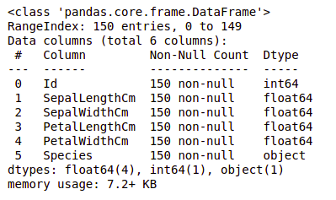
Output:

We can see that only one column has categorical data and all the other columns are of the numeric type with non-Null entries.
Let's get a quick statistical summary of the dataset using the describe() method. The describe() function applies basic statistical computations on the dataset like extreme values, count of data points standard deviation, etc. Any missing value or NaN value is automatically skipped. describe() function gives a good picture of the distribution of data.
Description of dataset
df.describe()
Output:
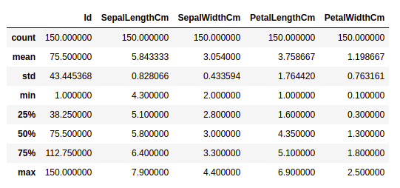
We can see the count of each column along with their mean value, standard deviation, minimum and maximum values.

Checking Missing Values
We will check if our data contains any missing values or not. Missing values can occur when no information is provided for one or more items or for a whole unit. We will use the isnull() method.
python code for missing value
df.isnull().sum()
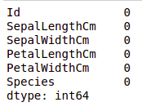
Output:

We can see that no column has any missing value.

Checking Duplicates
Let's see if our dataset contains any duplicates or not. Pandas drop_duplicates() method helps in removing duplicates from the data frame.
Pandas function for missing values
data = df.drop_duplicates(subset ="Species",)
data
Output:
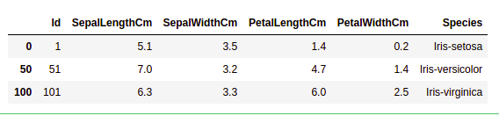

This function returns a Series containing counts of unique values.
Python code for value counts in the column
df.value_counts("Species")
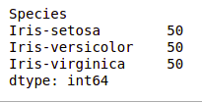
Output:
We can see that all the species contain an equal amount of rows, so we should not delete any entries.

Relation between variables
We will see the relationship between the sepal length and sepal width and also between petal length and petal width.
Comparing Sepal Length and Sepal Width
import seaborn as sns
import matplotlib.pyplot as plt

sns.scatterplot(x='SepalLengthCm', y='SepalWidthCm',
hue='Species', data=df, )

plt.legend(bbox_to_anchor=(1, 1), loc=2)
plt.show()
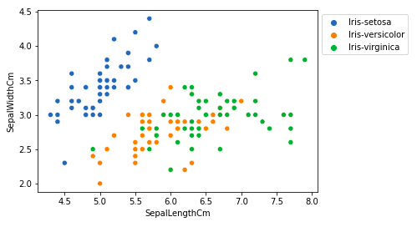
Output:
From the above plot, we can infer that -
- Species Setosa has smaller sepal lengths but larger sepal widths.
- Versicolor Species lies in the middle of the other two species in terms of sepal length and width
- Species Virginica has larger sepal lengths but smaller sepal widths.
Comparing Petal Length and Petal Width
import seaborn as sns
import matplotlib.pyplot as plt

sns.scatterplot(x='PetalLengthCm', y='PetalWidthCm',
hue='Species', data=df, )

plt.legend(bbox_to_anchor=(1, 1), loc=2)
plt.show()
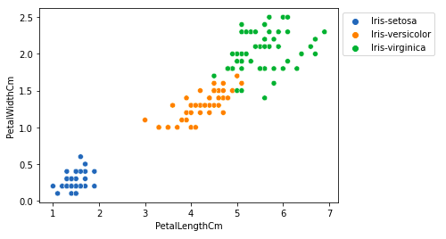
Output:

From the above plot, we can infer that -
- The species Setosa has smaller petal lengths and widths.
- Versicolor Species lies in the middle of the other two species in terms of petal length and width
- Species Virginica has the largest petal lengths and widths.
Let's plot all the column's relationships using a pairplot. It can be used for multivariate analysis.
import seaborn as sns
import matplotlib.pyplot as plt

sns.pairplot(df.drop(['Id'], axis = 1),
hue='Species', height=2)

Handling Correlation
Pandas dataframe.corr() is used to find the pairwise correlation of all columns in the dataframe. Any NA values are automatically excluded. Any non-numeric data type columns in the dataframe are ignored.
Example:
data.corr(method='pearson')
Output:
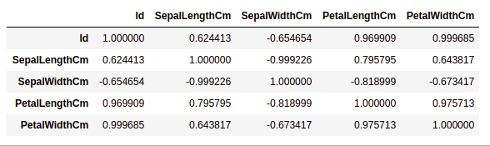

Heatmaps
The heatmap is a data visualization technique that is used to analyze the dataset as colors in two dimensions. Basically, it shows a correlation between all numerical variables in the dataset. In simpler terms, we can plot the above-found correlation using the heatmaps.
import seaborn as sns
import matplotlib.pyplot as plt

sns.heatmap(df.corr(method='pearson').drop(
['Id'], axis=1).drop(['Id'], axis=0),
annot = True);
plt.show()
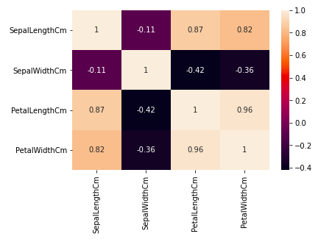
Output:

From the above graph, we can see that:
- Petal width and petal length have high correlations.
- Petal length and sepal width have good correlations.
- Petal Width and Sepal length have good correlations.

Handling Outliers
An Outlier is a data item/object that deviates significantly from the rest of the (so-called normal)objects. They can be caused by measurement or execution errors. The analysis for outlier detection is referred to as outlier mining. There are many ways to detect outliers and the removal process is the data frame same as removing a data item from the panda’s dataframe.
Let's consider the iris dataset and let's plot the boxplot for the SepalWidthCm column.
import seaborn as sns
import matplotlib.pyplot as plt

df = pd.read_csv('Iris.csv')

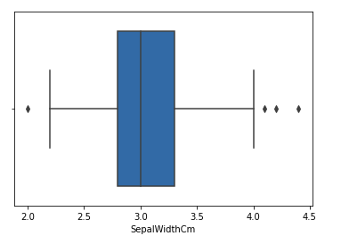
sns.boxplot(x='SepalWidthCm', data=df)
Output:
In the above graph, the values above 4 and below 2 are acting as outliers.

Removing Outliers
For removing the outlier, one must follow the same process of removing an entry from the dataset using its exact position in the dataset because in all the above methods of detecting the outliers end result is the list of all those data items that satisfy the outlier definition according to the method used.
We will detect the outliers using IQR and then we will remove them. We will also draw the boxplot to see if the outliers are removed or not.
import sklearn
from sklearn.datasets import load_boston
import pandas as pd
import seaborn as sns

df = pd.read_csv('Iris.csv')

Q1 = np.percentile(df['SepalWidthCm'], 25,
interpolation = 'midpoint')

Q3 = np.percentile(df['SepalWidthCm'], 75,
interpolation = 'midpoint')
IQR = Q3 - Q1

print("Old Shape: ", df.shape)

upper = np.where(df['SepalWidthCm'] >= (Q3+1.5*IQR))
lower = np.where(df['SepalWidthCm'] <= (Q1-1.5*IQR))

df.drop(upper[0], inplace = True)
df.drop(lower[0], inplace = True)

print("New Shape: ", df.shape)
sns.boxplot(x='SepalWidthCm', data=df)
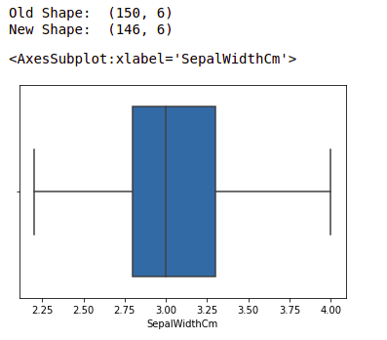
Output:

